v
GPC
New Nomination
Process Guide







Welcome to your new role!
This nomination guide is designed to streamline your nomination process. We encourage you to review the entire guide thoroughly before contacting the GPC team, as it addresses most frequently asked questions and can facilitate a smoother experience. All necessary links and documents for this process are located at the end of this guide.

The following visual provides a comprehensive overview of the nomination process, from initial nomination through to the finalization of your role with your AOPC:

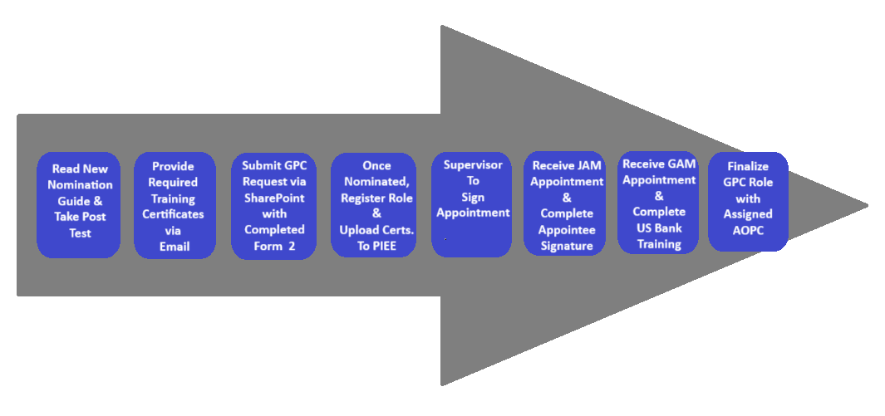
Below is a step-by-step guide to your nomination process:
Step 1:
Read this GPC New Nomination Process Guide in its entirety, then take the GPC New Nomination Process Post Test here:

https://www.classroomclipboard.com/982219/Test/AE431EBC-10C2-42E8-9B28-490AD2BD92A4

Step 2:

GPC Training Requirements
Prior to submitting a nomination request, please confirm that all necessary trainings for your role have been completed and that you have obtained the relevant certificates. In addition, please verify that your supervisor has fulfilled their training requirements as well.

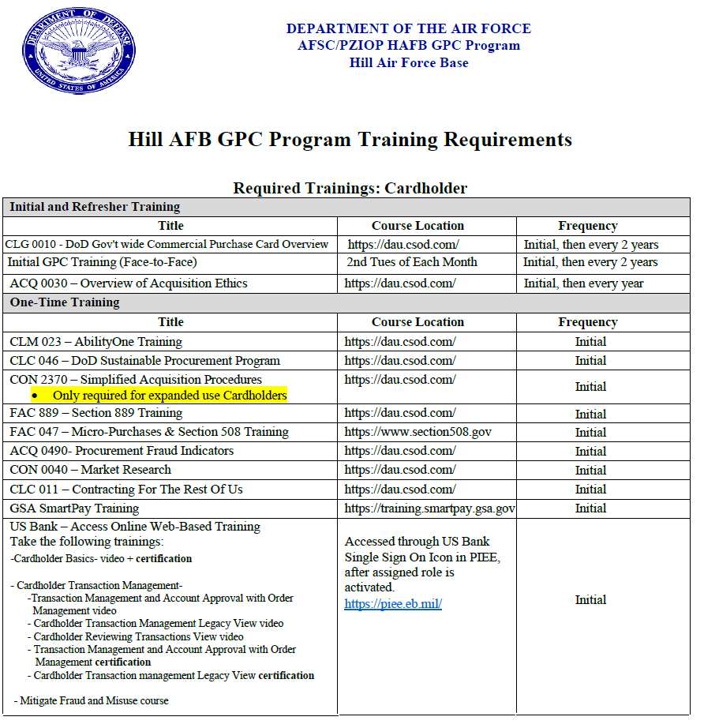

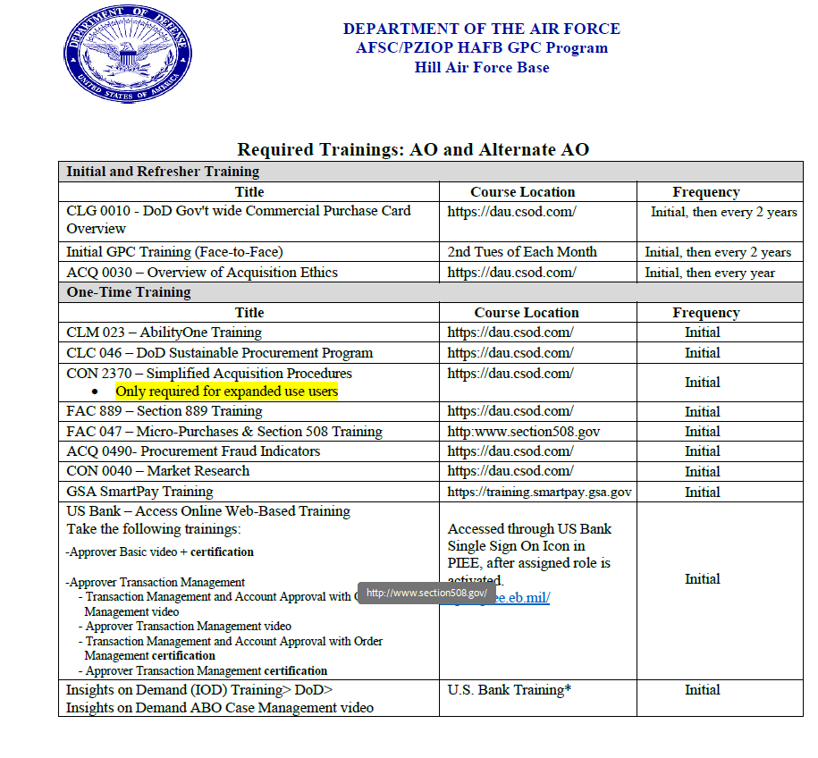

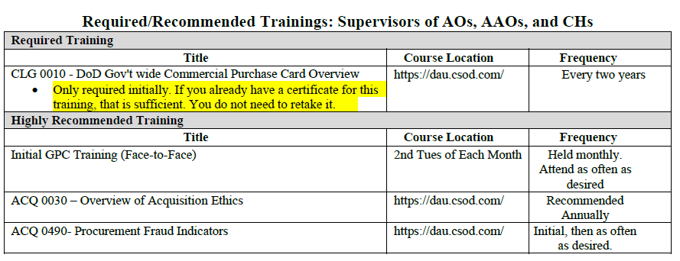

Step 3:

Request For GPC Assistance
- Choose ‘Request for GPC Assistance’
- Choose ‘Add new item’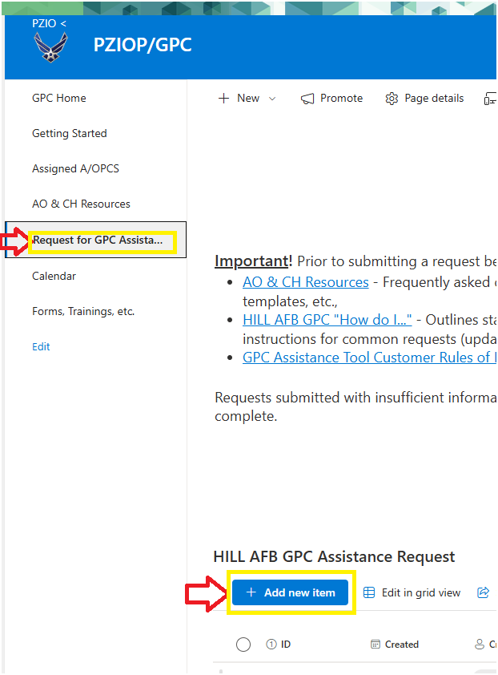
- Choose ‘PIEE Nomination’ as your ‘Type of Issue’ and ensure to fill out every section with red asterisk.

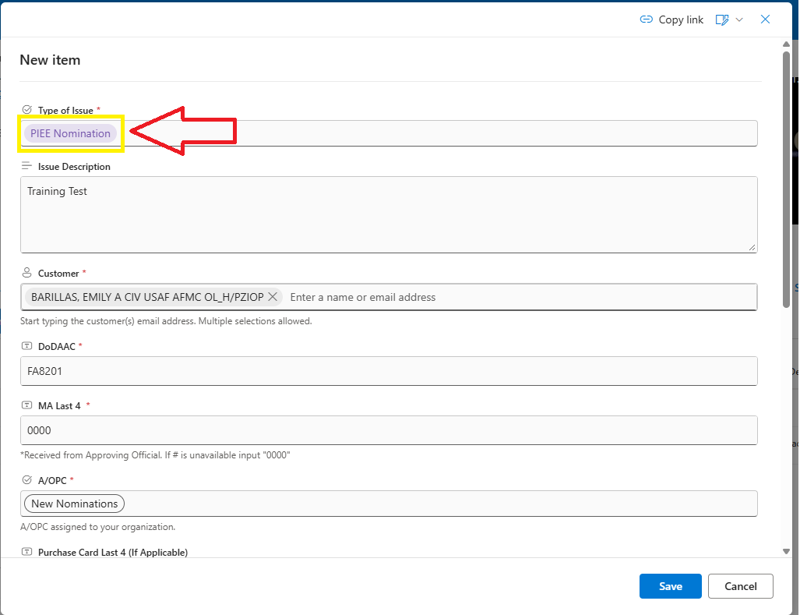

- Please upload your completed Form 2 under the "Add attachments" section. Once uploaded, please confirm that you have taken the test by leaving a comment in the message box located in the upper right corner of the page.
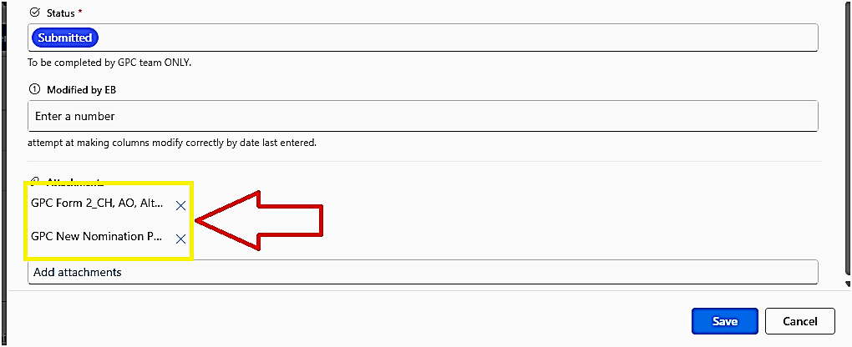

NOTE: Following each step in the nomination process, please provide an update to the GPC team via SharePoint messages/comments. This notification is crucial for us to understand your progress and authorize the next stage. To ensure your message is received, please use the “@” symbol followed by Emily Barillas in the comment section of SharePoint. This will directly notify them of your update.
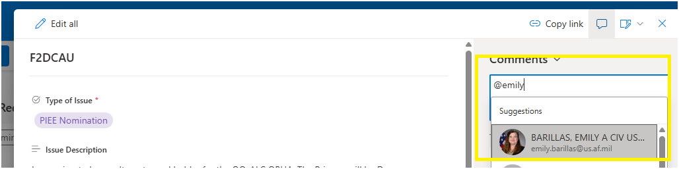

Step 4:

Uploading Training To PIEE
- Once you have completed all required training, and together with your SharePoint request, please upload your documentation and certificates to the "My Training" section of your PIEE account. If you are a new user and do not yet have a PIEE account, please email your certificates to your nominator. They will upload them to the system on your behalf after you have been nominated.
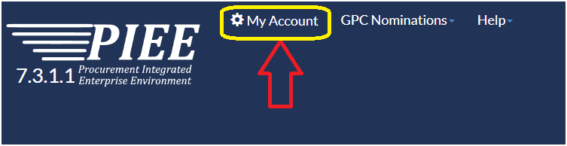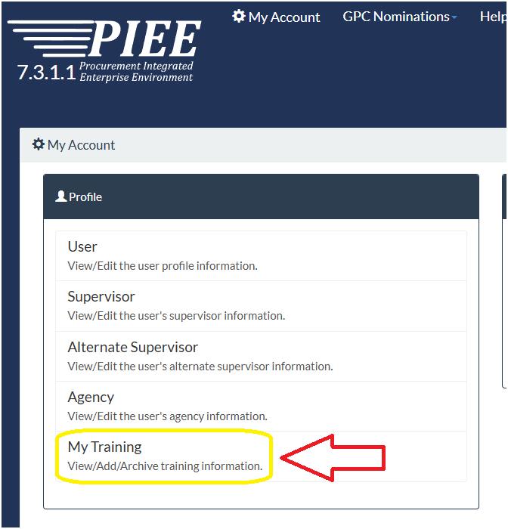
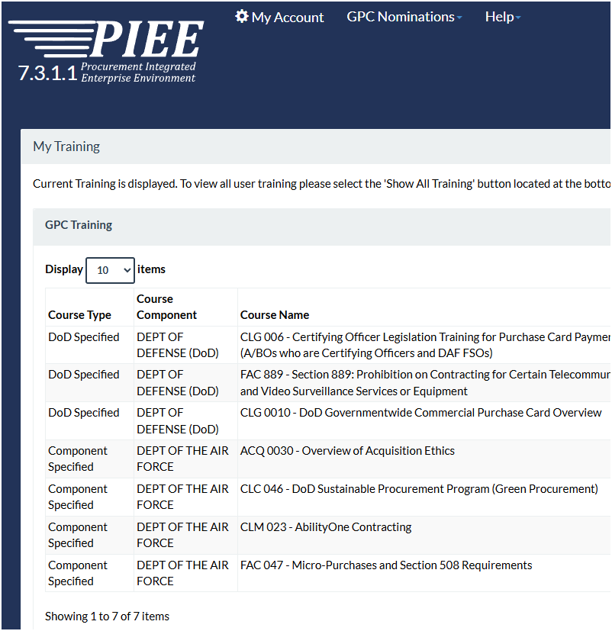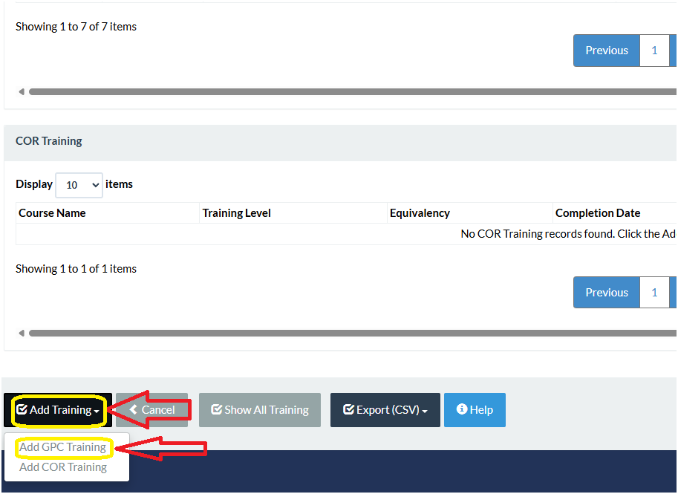

NOTE: Please verify the correct renewal frequency for each certificate, as this will impact future reporting and renewal notifications:

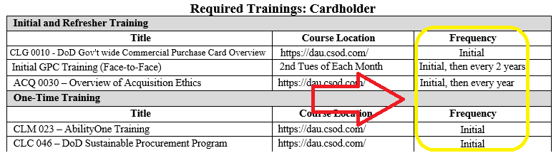
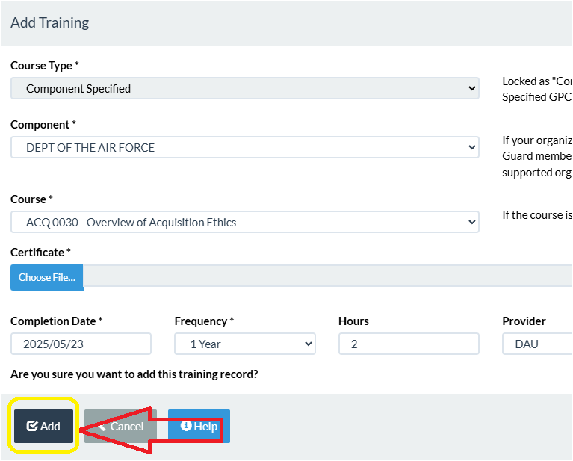

Should you encounter any difficulties uploading your documents, please contact the PIEE help desk at 866-618-5988 for assistance.
Step 5:

Register Your Role
You are now ready to register your role. Below is the 12-step process to register your role
found in the auto email you will have received from PIEE:

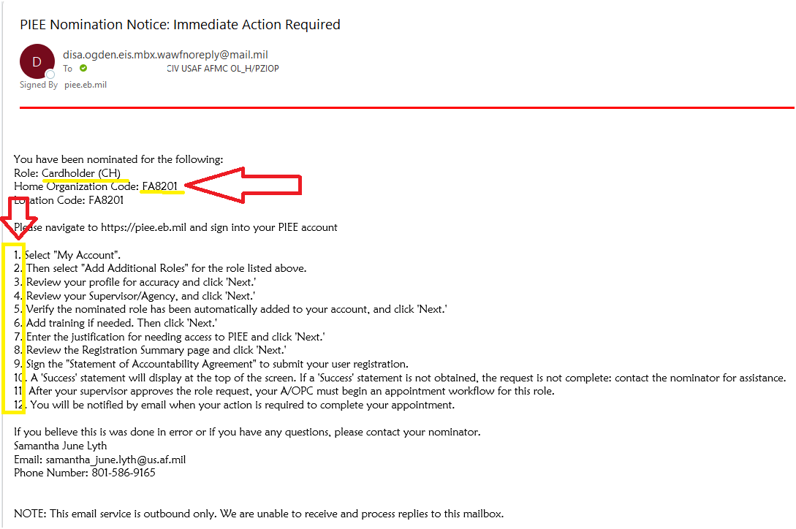
1-Select “My Account”
2- Then select “Add Additional Roles” for the role listed above.
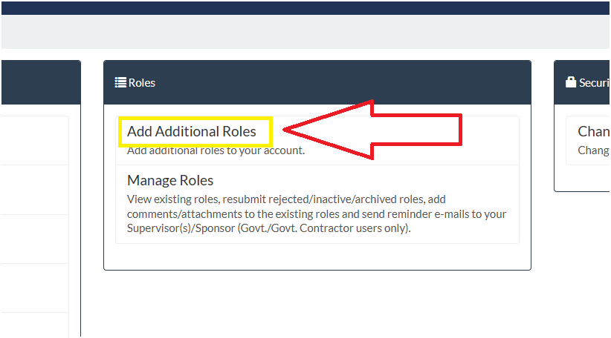
3- Review your profile for accuracy and click “Next”.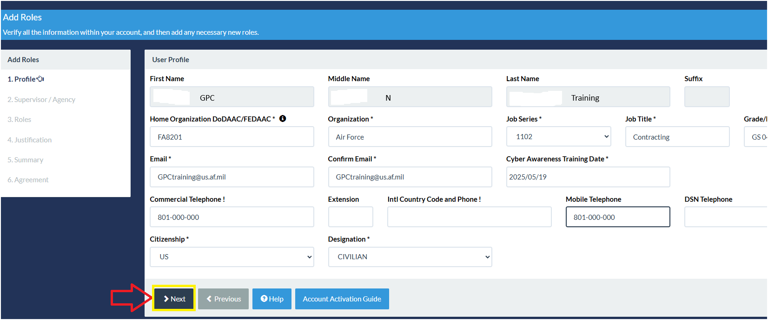
3- Review your profile for accuracy and click “Next”.

3A- If you have an active warrant, please click “Yes”. If unsure, verify with your supervisor.
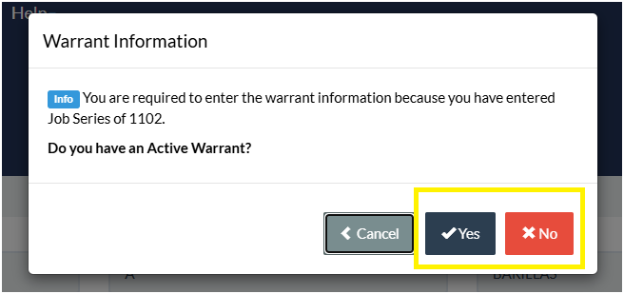

4- Review your Supervisor/Agency and click “Next”.
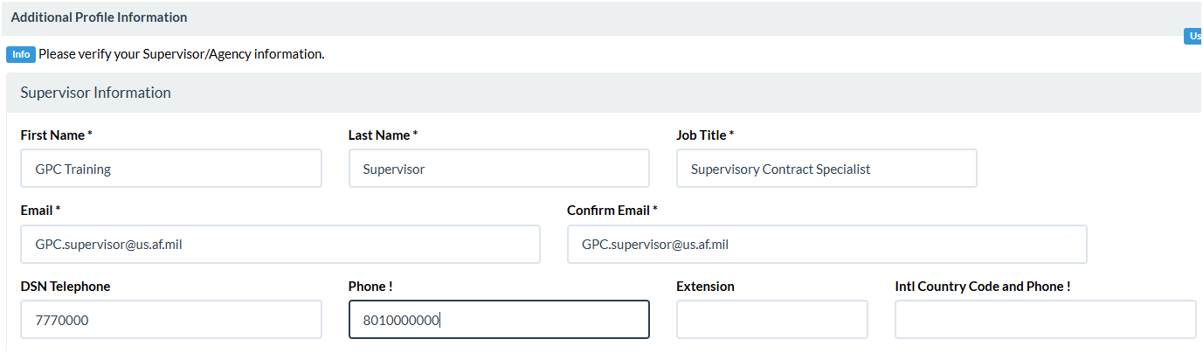
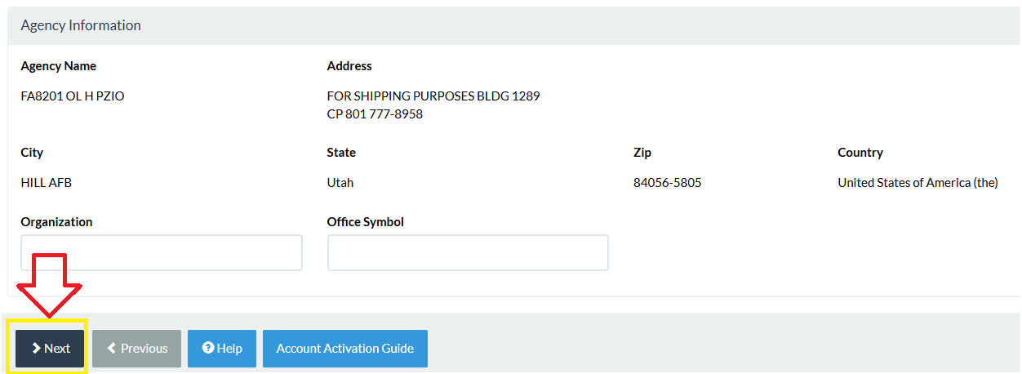

5- Verify the nominated role was automatically added to your account and click “Next”.
- CH Role: Purchase Card->Cardholder (CH)-> Location Code FA8201-> Next
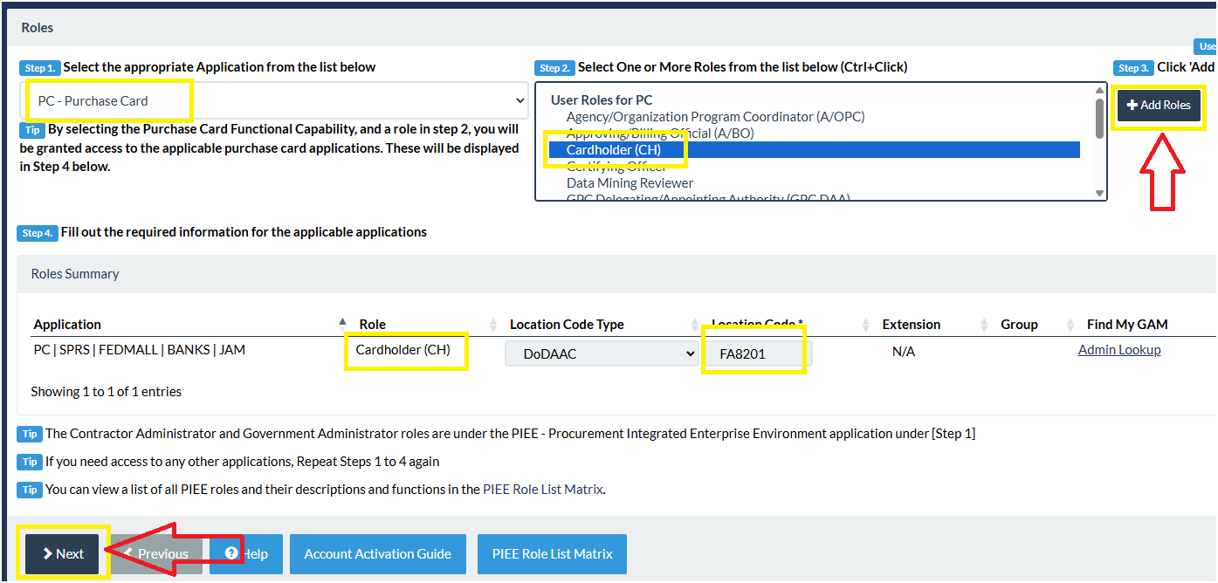

- AO Role: Purchase Card-> Approving/Billing Official (A/BO)->
Location Code FA8201->Next
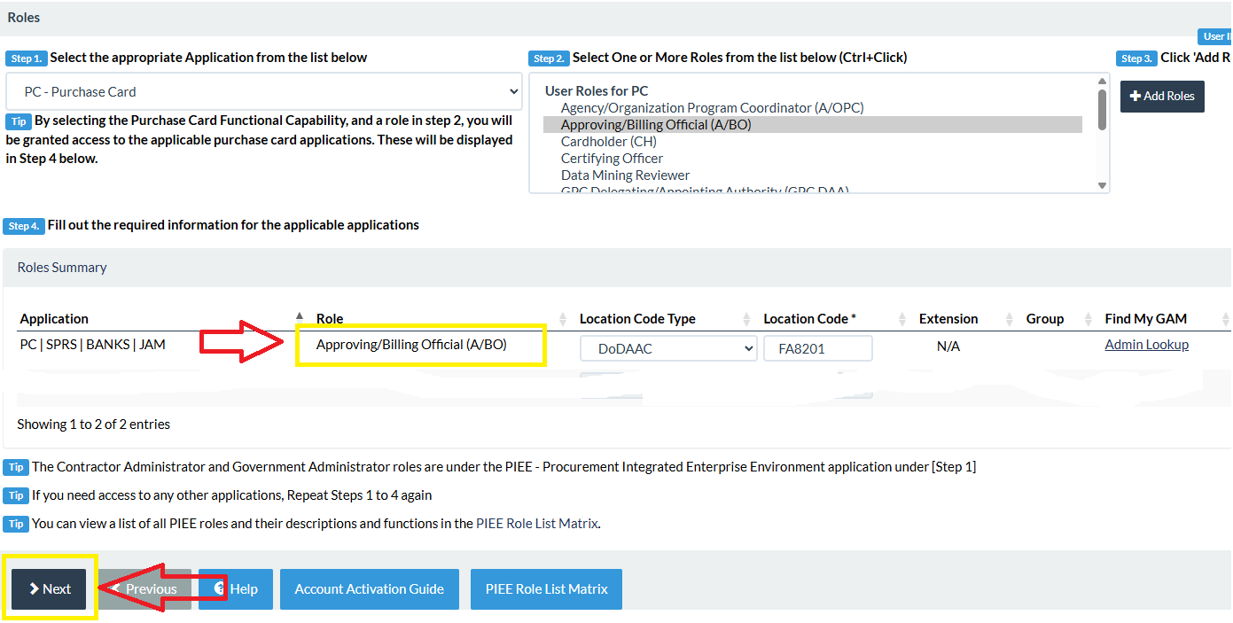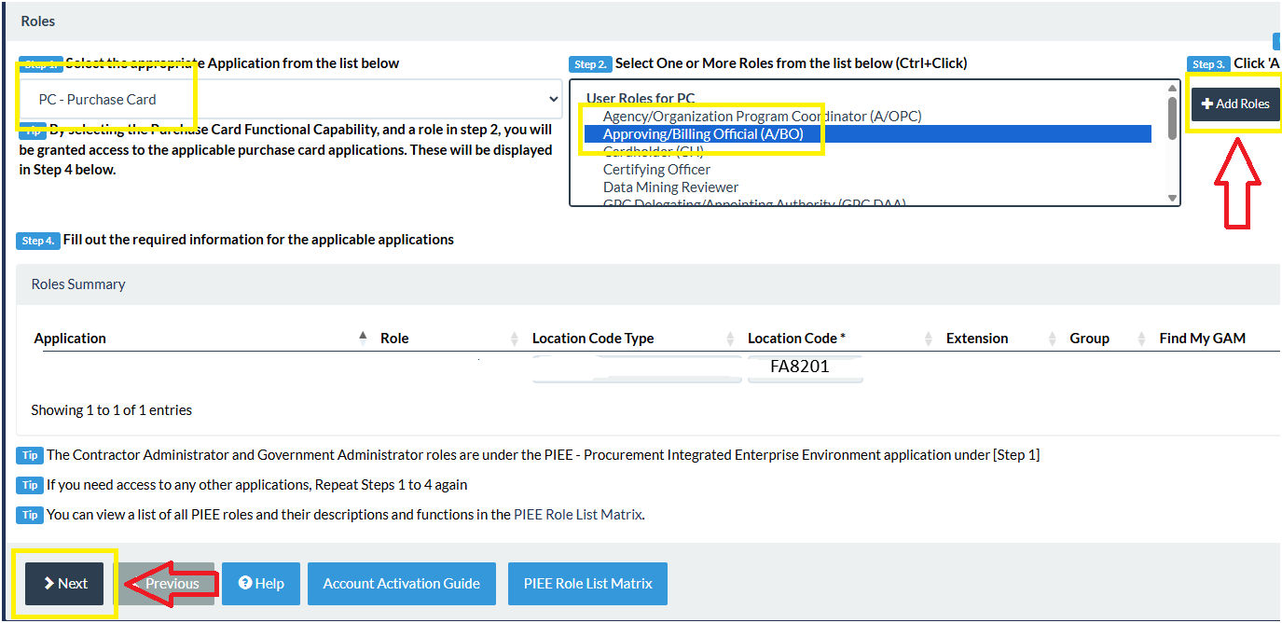

6- Add training if needed. Then click “Next”.
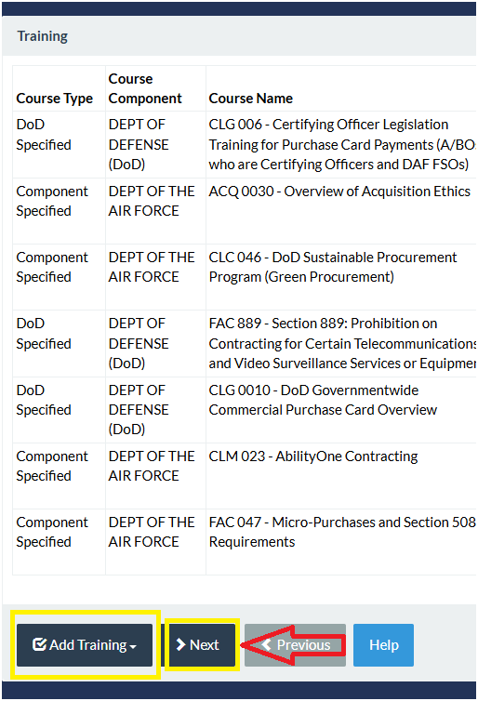
7- Enter the justification for needing access to PIEE and click “Next”.
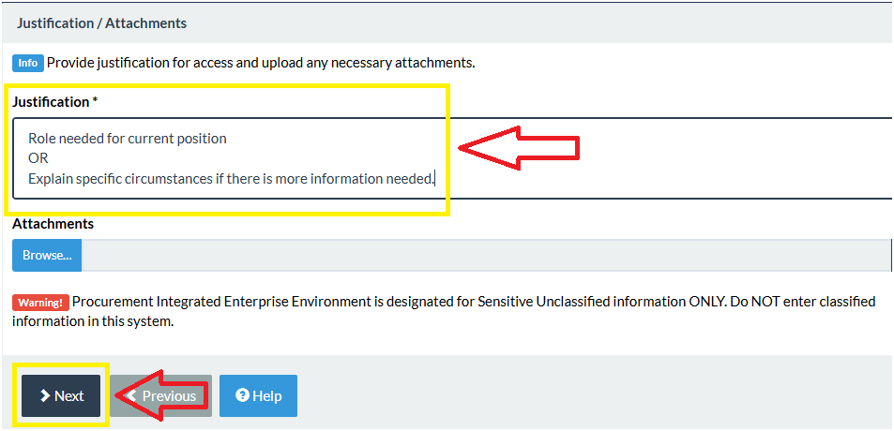

8- Review the Registration Summary page and click “Next”.
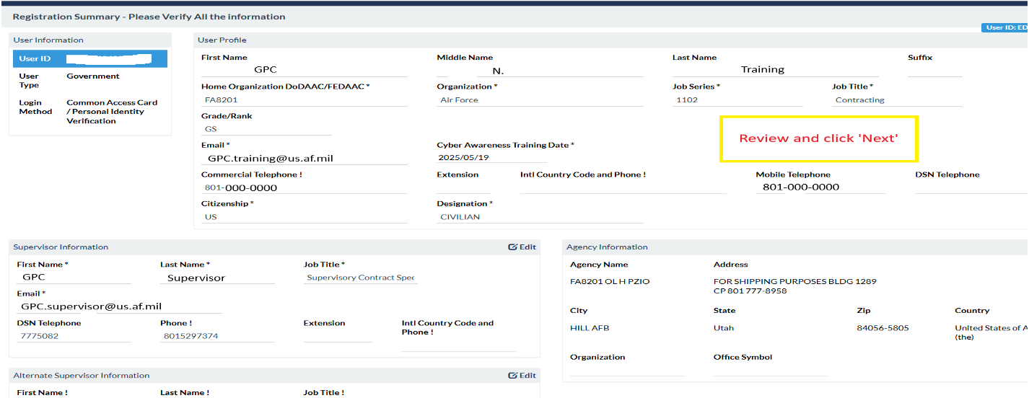
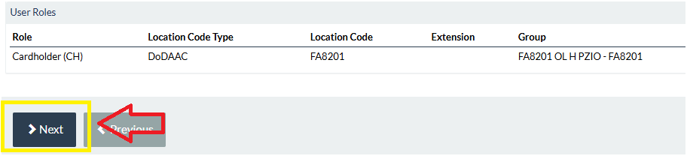

9- Sign the "Statement of Accountability Agreement" to submit your user registration.
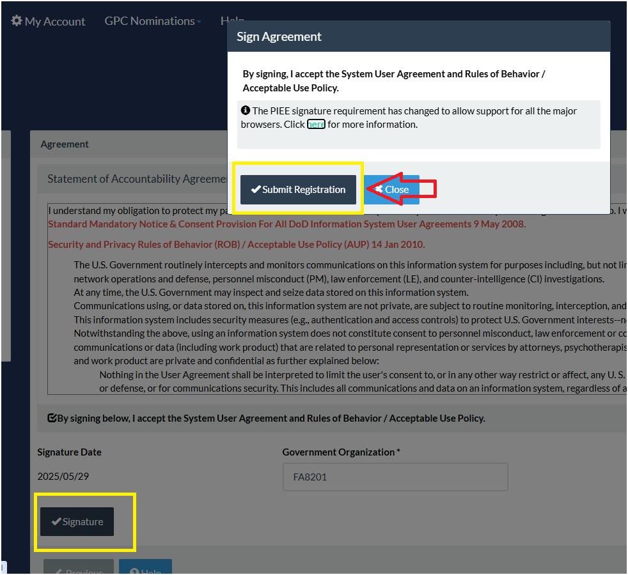
10- A 'Success' statement will display at the top of the screen. If a 'Success' statement is not obtained, the request is not complete: contact the nominator for assistance.
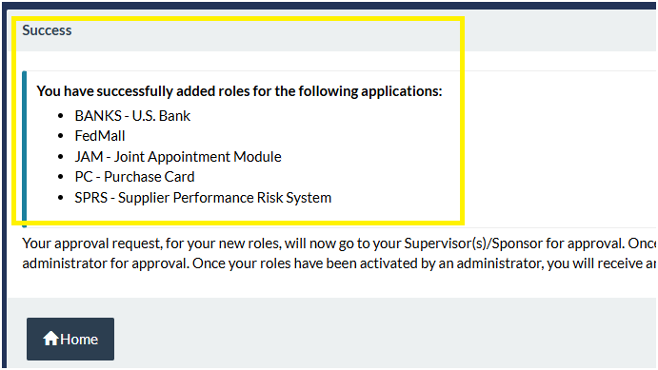
You are now registered for your role:

Registration Status
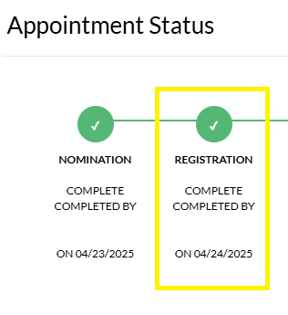

11- After your supervisor approves the role request, your A/OPC must begin an appointment workflow for this role. To verify if your supervisor has approved your role, you can click. You can also check the progress of your nomination at any time through this method:

Step 5:

Supervisor Approval

My Account->Manage Roles->View-> You will see Approval (green circle) or
No Approval (no green circle)
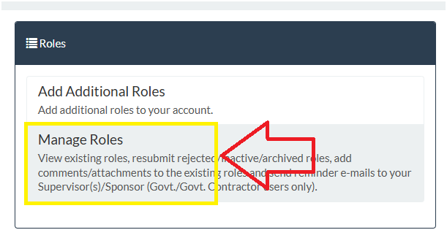
No supervisor approval:
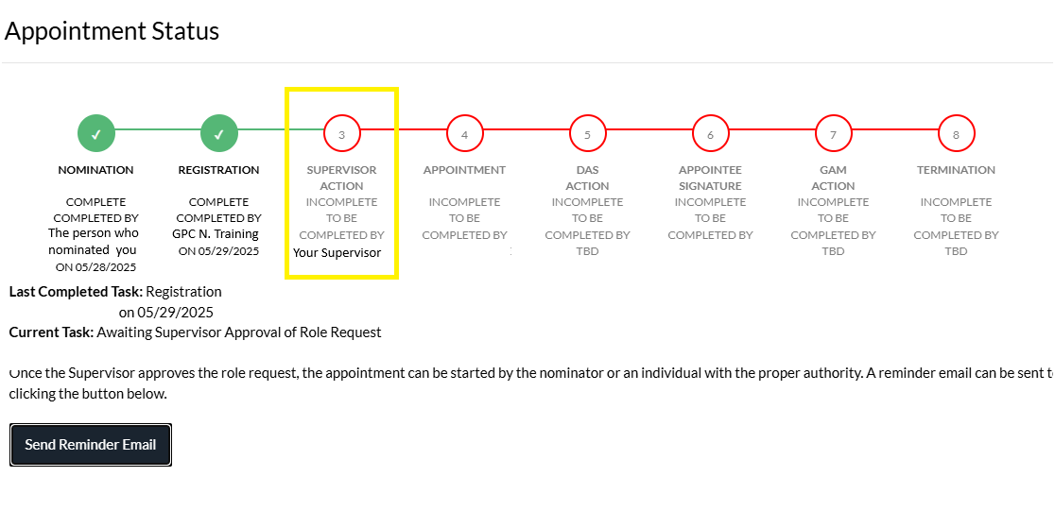
Supervisor approval:
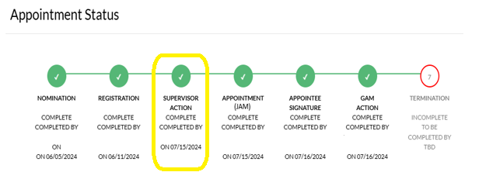
12- You will be notified by email when your action is required to complete your appointment. Once you see supervisor approval, you are ready for your first appoinment in JAM. Please provide an update to the GPC team via SharePoint messages/comments.
NOTE: The following visual represents the process as it appears within your PIEE account when all steps are complete for nomination:
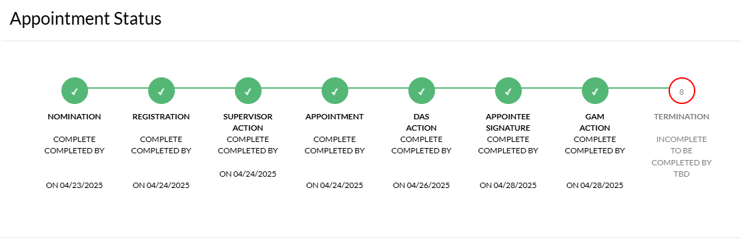
Step 6:

JAM Approval
Your nomination is now ready for the first of two approval stages through JAM.
Please provide an update to the GPC team via SharePoint messages/comments.
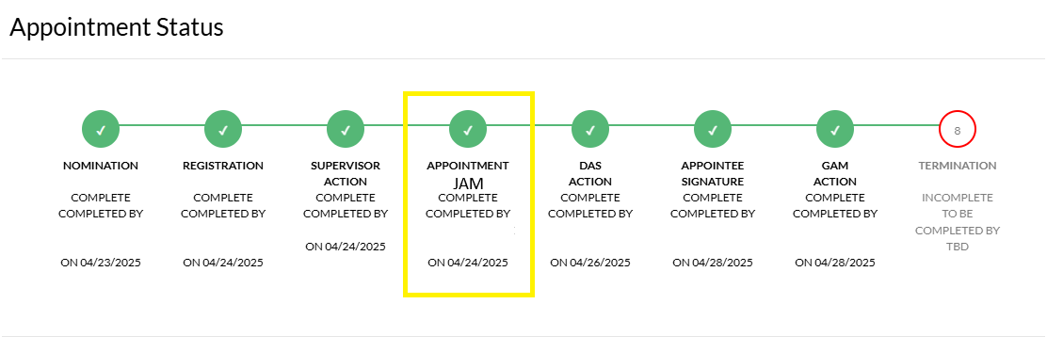
Step 7:
Your nomination will pass through a DAS approval (GPC initial approval). Please be watching your account to complete your next step.
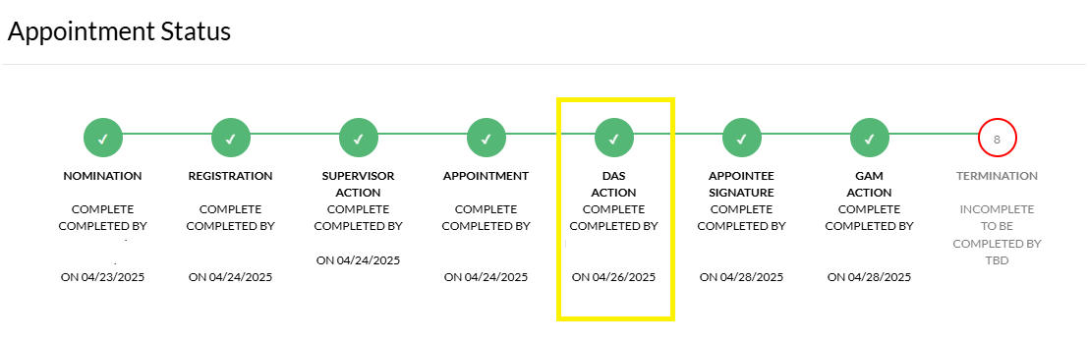
Step 8:

Appointee Signature
Upon JAM approval, you will receive an automated notification via PIEE and will be prompted to complete your appointee signature. Please provide an update to the GPC team via SharePoint messages/comments.
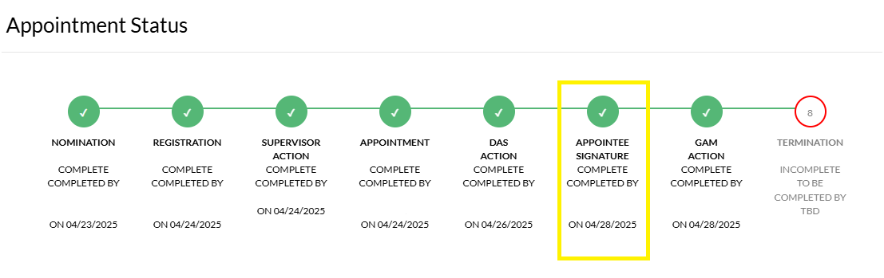
Step 9:

GAM Approval
At this stage, your nomination will be submitted for GAM approval. Once GAM is approved, you may proceed with completing your required U.S. Bank trainings. Once you have finished all required U.S. Bank trainings, please provide an update to the GPC team via SharePoint messages/comments.
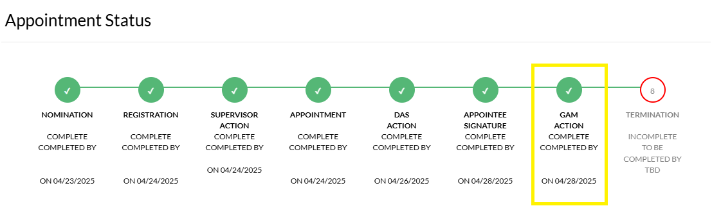

Step 10:
The individual who created your nomination or your assigned AOPC will set you up in the bank once you are GAM approved. If for some reason your U.S. Bank app is not appearing on your PIEE dashboard, please contact your nominator/AOPC.

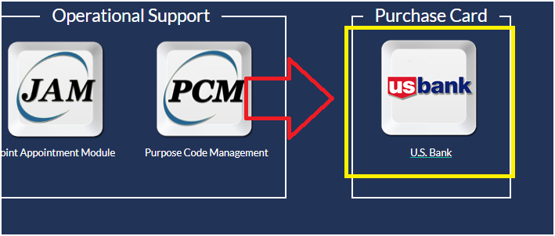

NOTE:

U.S. Bank Access Online may experience occasional timeouts or errors. As a preliminary troubleshooting step, consider logging out of your session and then logging back in. In addition, many times the video trainings can take up to two minutes to load. Keep the window open to allow it to buffer. The audio will auto start once it is ready.

It can be hard to find the needed trainings at times. We recommend finding your required trainings by using the Search Bar.

If you are using Chrome and having a hard time with drop down menus in US Bank, we recommend you switch to Edge.

US Bank Access Online Trainings
Click on: Need help? -> Training->Search

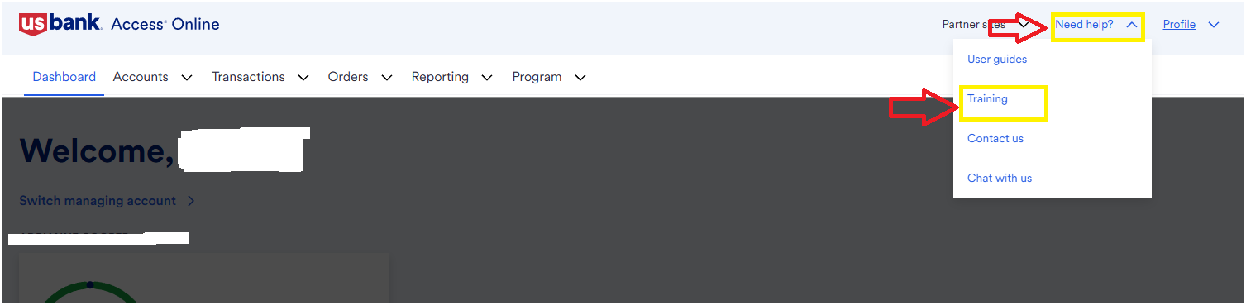

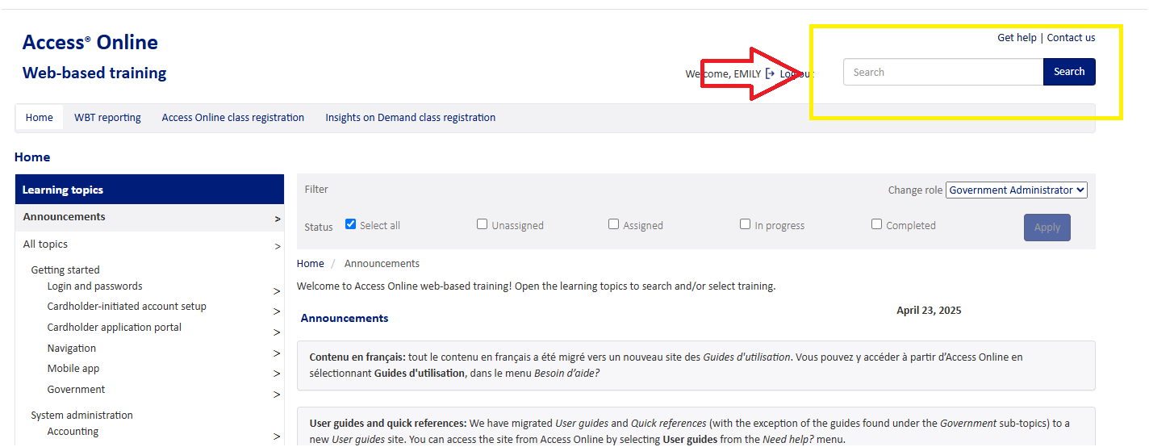
CH Trainings:
Navigation basics-> Common tasks & Cardholder tasks
Account approval process
Statements
Transaction management

AO Trainings:
Navigation basics
Statements
Account approval process
Transaction management
Transaction management-> transaction management & account approval process
Order management
Order management set up
IOD-> DoD> Role Based Training & ABO Case Management
Step 11:
Once you have finished all your required UA Bank trainings, you are now ready to work with your AOPC to finalize your card/process. Please provide an update to the GPC team via SharePoint messages/comments. You can access the chart to locate your AOPC below:

Assigned AOPCs
Assigned AOPC.docx

Please find your assigned AOPC in the above list. The individual who has processed your nomination will be contacting your AOPC shortly. Please be patient, and your AOPC will contact you once they are ready to process your role.

Thank you for investing your time and effort in understanding the nomination process. Your commitment to learning the procedures contributes to a more efficient and streamlined experience for everyone involved.

Good luck in your new role!

- Your GPC Team

Important Links

SharePoint site:
https://usaf.dps.mil/sites/AFSC-PK/PZIO/PZIOP/SitePages/Home.aspx

Form 2:
GPC Form 2_CH, AO, Alt AO Request Form (Form 2).pdf

CH and AO GPC Training Guide:
CH and AO GPC Training Guide CAO 08-28-25.pdf

GPC New Nomination Post Test:https://www.classroomclipboard.com/982219/Test/AE431EBC-10C2-42E8-9B28-490AD2BD92A4
Access Code: K5HD8
PIEE:
https://piee.eb.mil/xhtml/unauth/home/login.xhtml

